
Bundaberg

10 Eastgate Street,
East Bundaberg, Qld. 4670
P.O. Box 740
Bundaberg, Qld. 4670

Phone (07) 4151 5825
info@bmow.com.au



2024
P R E – O R D E R E D
F R O Z E N M E A L S

Beef - Roast Beef – Roast Potato & Pumpkin, Beans NPP LF DVF GF
Curried Sausages- Mash Potato, Carrot, Peas GF Sp NPP
Port & Orange Braised Beef – Steamed Potato, Carrot, Broc NPP DF GF DVF
Beef Patti & Dianne Sauce
Cottage Pie- Mixed Vege NPP GF
Beef Stroganoff - Sweet Potato, Mash Cauli, Peas NPP GF G

Lamb- Mongolian Lamb – Steamed Potato, Corn, Broc NPP DF GF G
Lamb Casserole - Mash Potato, Mixed Veg GF NPP DF
Roast Lamb- – Roast Potato & Rst Pumpkin, Peas NPP GF DF
Moroccan Lamb – Rice, Mixed Veg NPP DF G GF
Lamb Meatballs & Napoli Sauce-

Pork – Pork Sausages & Gravy – Mash, Carrot, Peas – GF
Pork & Prune – Mash Potato, Cauli, Beans GF G
Roast Pork- Roast Potato, Rst Pumpkin, Peas- GF DF GF
Sweet & Sour Pork – Rice Mixed Veg DF
Quiche Lorraine-

PLEASE NOTE: Vegetable component may vary.
Chicken –
Honey Mustard Chicken – Swt Pot Mash, Cauli, Beans DF GF NPP
Chicken Schnitzel & Gravy – Rst Swt Pot, Cauli, Beans DF NPP DVF
Curry Chicken – Rice, Carrot, Beans NPP Sp GF G DVF
Chicken & Vege Pie (carrot, onion, broc) – Sweet Potato, Peas, Cauli DF NPP
Roast Chicken (Skin on) & Gravy – Roast Potato, Pumpkin, Beans DF GF NPP
Creamy Italian Chicken – Rice, Cauli, Peas NPP GF G

Fish -
Crumbed fish – Potato Bake, Carrot, Brocc- DVF NPP
Salmon Potato Pie-

Pasta - Spaghetti Bolognaise- Cauli, Beans G NPP
Tuna Bake – Roast Carrot, Brocc NPP DVF
Bacon Carbonara- Steam Vegetables

Vegetarian Meals-
Vegetable Frittata – Tuscan Mash, NPP, GF, DVF, G
Bean & Noodle Stir Fry- Corn, Peas DF GF NPP
Spinach & Cheese Roll- Mash, Carrot, Peas – NPP
Plant Based Vegetable Schnitzel & Gravy – Chats, Cauli, Broc- NPP DF
Pumpkin & Ricotta Roll- Mash, Corn, Beans – NPP
Mediterranean Pasta – Carrot, Broc NPP G DF
Roast Vegetable Risotto – Mixed Veg GF G
Mushroom Risotto – Carrot Broc NPP GF G DVF
Vegetarian Fried Rice- Rst Pumpkin, Cauli- DF GF NPP G
Pumpkin Arancini Balls- Carrot, Beans -NPP, G, DVF
Plant Based Parmigiana- Mash, Mix Vege
Vegetarian dishes may vary depending on availability and Chefs choice.

LF Lactose Free
GF Gluten Free
DVF Diverticular Friendly
NPP No Pork Products
G Garlic
Sp Spice

Bundaberg

(My Aged Care registered clients)
Meal Package PRICE INCREASE to $13.00 As of November 1st, 2024
Meal Package
$11.00 ($13.00)
Frozen Meal Package components: Main, Dessert, Soup, Juice
You can swap components of this package EG. a soup for a 2nd dessert or swap a juice for a 2nd soup
any combination of 1 meal + 3 sides.
F R O Z E N S O U P S
$2.00 each
We have a variety of frozen soups available.
Please ask office staff.
FROZEN MAINS
$8.00
FROZEN DESSERTS
$3.00
J U I C E S $1.00 each
Apple Apple & Blackcurrant Orange Juice

Bundaberg

P R E – O R D E R E D
F R O Z E N D E S S E R T S
$2.00 each

- Jelly & Custard
- Jelly and Fruit
- Chocolate Cake DVF
- Carrot Cake
- Banana Cake
- Orange Cake
- Assorted Mousse
- Cherry Ripe Slice
- Tiramisu
- Apple Crumble
- Trifle
- Assorted Panna Cotta
- Passionfruit Slice
- Lemon Meringue
- Pavlova
- Mud Cake
- Black Forest Cake
- Cheesecake
- Apple Crumble
- Custard & Fruit
- Crème Brule & Prunes

Apple

Bundaberg
10 Eastgate Street,
East Bundaberg, Qld. 4670
P.O. Box 740
Bundaberg, Qld. 4670

Phone (07) 4151 5825
info@bmow.com.au

B R E A K F A S T B O X
$3.00 each
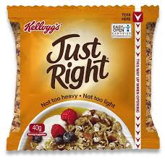
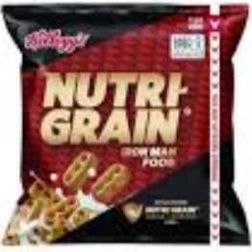
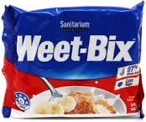
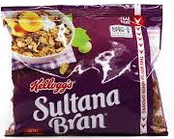
Choose a cereal.

Plus, all this
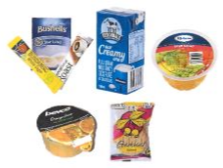

Contents: 1x Cereal Sachet (of your choice), 1x Tea Bag, 1x Coffee Stock, 1x Sugar Stick, 1x 150ml UHT Milk,
1x Fruit Salad Cup, 1x Orange Juice & 1x Oatmeal Twin Cookie

Home Delivered Meals Service Information
To Your Door Within Our Delivery Area

Delivery
Meals delivered within the Bundaberg area include Moore Park, Burnett Heads, Bargara, Innes Park, Coral Cove, Parklands Estate. Please ask the office if we deliver to your area and what days.
Meals are delivered by our friendly volunteers, providing Hot, Chilled and Frozen options delivered daily, Monday to Friday between 10:30 am to 12:30 pm.
We are closed Public Holidays so we offer alternate arrangements.
You must be home for your meal to be delivered. If this does not suit we can make other arrangements such as access to a working fridge, access to a key box, ask a neighbour. Food safety regulations prohibit meals being left in an esky or chiller bags with ice bricks. You can choose to collect from the office as long as sufficient notice is given.

